Primary activity ideas

Introduction
Introduction
No Pens Day Wednesday activity ideas have been created by practising teachers and speech and language therapists. These have then been quality assured by a specialist speech and language therapist to ensure they are fit for purpose.
Activity ideas are more generic than the lesson plan templates and can be adapted to any lesson or session. They give some information about the activity and how it can be implemented, highlighting any resources or links that might be useful to support that activity. These activities can be used in many ways: as a starter activity, main activity, plenary or as methods of recording learning. We also have separate guidance on ways of recording, assessing and monitoring pupil progress without using pens (available on the No Pens Day Wednesday materials page under information for staff).
How do no pens activities support pupils with special educational needs and disabilities (SEND)?
The aim of No Pens Day Wednesday is to include all children in spoken language activities to support their learning. This includes children who require SEN support, many of whom will have speech, language and communication needs (SLCN).
These activities allow a focus to be placed on communication and language in your setting, even if only for part of a lesson or session. By doing this, you may find that you’re more able to spot those children who are struggling with their speech, language and communication development. For those children who have already been identified as requiring SEN support, placing a focus on spoken language means that you are encouraging them to develop their skills in this important area of their development, which is the foundation for so much of their learning.
You might also want to adapt activity ideas to link with any objectives that have been set by specialist colleagues, such as a speech and language therapist.
You can find out more about identifying and supporting children with SEND, and in particular those with SLCN in our pack of strategies for every classroom, which can be found in the information for staff section of our website.



Do I fit?
This activity can be useful as part of a plenary to help consolidate what students have learned during a lesson, particularly specific topic vocabulary.
Spoken language and listening objectives:
- Asking questions
- Justifying answers
- Using and understanding new topic vocabulary
Resources:
- Sentence strips based on a specific topic, with missing key words
- Key words/phrases to match the sentence strips
Activity:
Give half the class some sentence strips, with some key words missing. Give the other half key word cards that will fit with the sentence strips that the other group has.
Ask children to move around, with the aim being to find their partner – i.e. the person who will help them make their sentence complete. Encourage discussion as children move around the room trying to find their sentence partner; they’ll need to ask questions of each other and talk about why they are/aren’t sentence partners.
Extension:
Once children have found their partner, they can read their sentence to the rest of the class and explain how they reached their decision that they were partners, for example, “I knew that I needed to put the word ‘share’ in there because otherwise the maths problem wouldn’t have made sense”.
Reflection:
- What did you need to do to find your sentence partner?
- Was it easy to find your partner?
- Were there any other possibilities as to who could have been your partner? Why?
Podcast
This activity is a useful means of recording children’s spoken language skills. It can be adapted to be used for any lesson.
Spoken language and listening objectives:
- Using language to summarise learning
- Using language for a variety of functions (giving instructions, telling a story, asking/answering questions)
Resources
- Digital voice recorder or video recorder

Activity:
Explain to the children that this activity allows them to share their learning, without having to use writing to prove what they know and have learned.
Depending on the lesson, the podcast may take several different forms, it might be about the outcome of an experiment, the method used to do an experiment, explaining how to solve a maths problem, an interview with a historical character, the rules of playing football etc. The podcast could even be a review of a lesson, encouraging children to use self assessment for their learning.
Extension:
You could encourage the class to listen to other podcasts that are available and talk about why they like/don’t like them, any ideas as to how they could be better, anything that they haven’t understood etc.
Reflection:
- What did students have to think about in terms of their language when they were doing a podcast?
- How is it different to using language face-to-face?
- Are podcasts a useful way to share information?

Word Magic
This activity helps children to remember new vocabulary by making associations between a word and other information - this helps children to store and retrieve new words.
Spoken language and listening objectives:
- Understanding and using topic vocabulary
- Defining words
Resources
- Word web template (provided - taken from I CAN’s Communication Cookbook, available from www.ican.org.uk/cookbook)
Activity:
Place a new word in the centre of the word web. As a group, work through the word web, asking children to fill out the different parts.
Summarise the word web to give a summarised definition of the word. Then, look the word up in the dictionary – how do the definitions compare?
Extension:
Play this the other way round – with the arms of the word web filled in and ask children to guess what the word in the centre might be....
Reflection:
- Is it helpful to break down words like this? Why?
- Do we know any other words that are similar to the one that’s in the word web?
- Is everybody now able to think of/tell the rest of the class a sentence that includes the word?
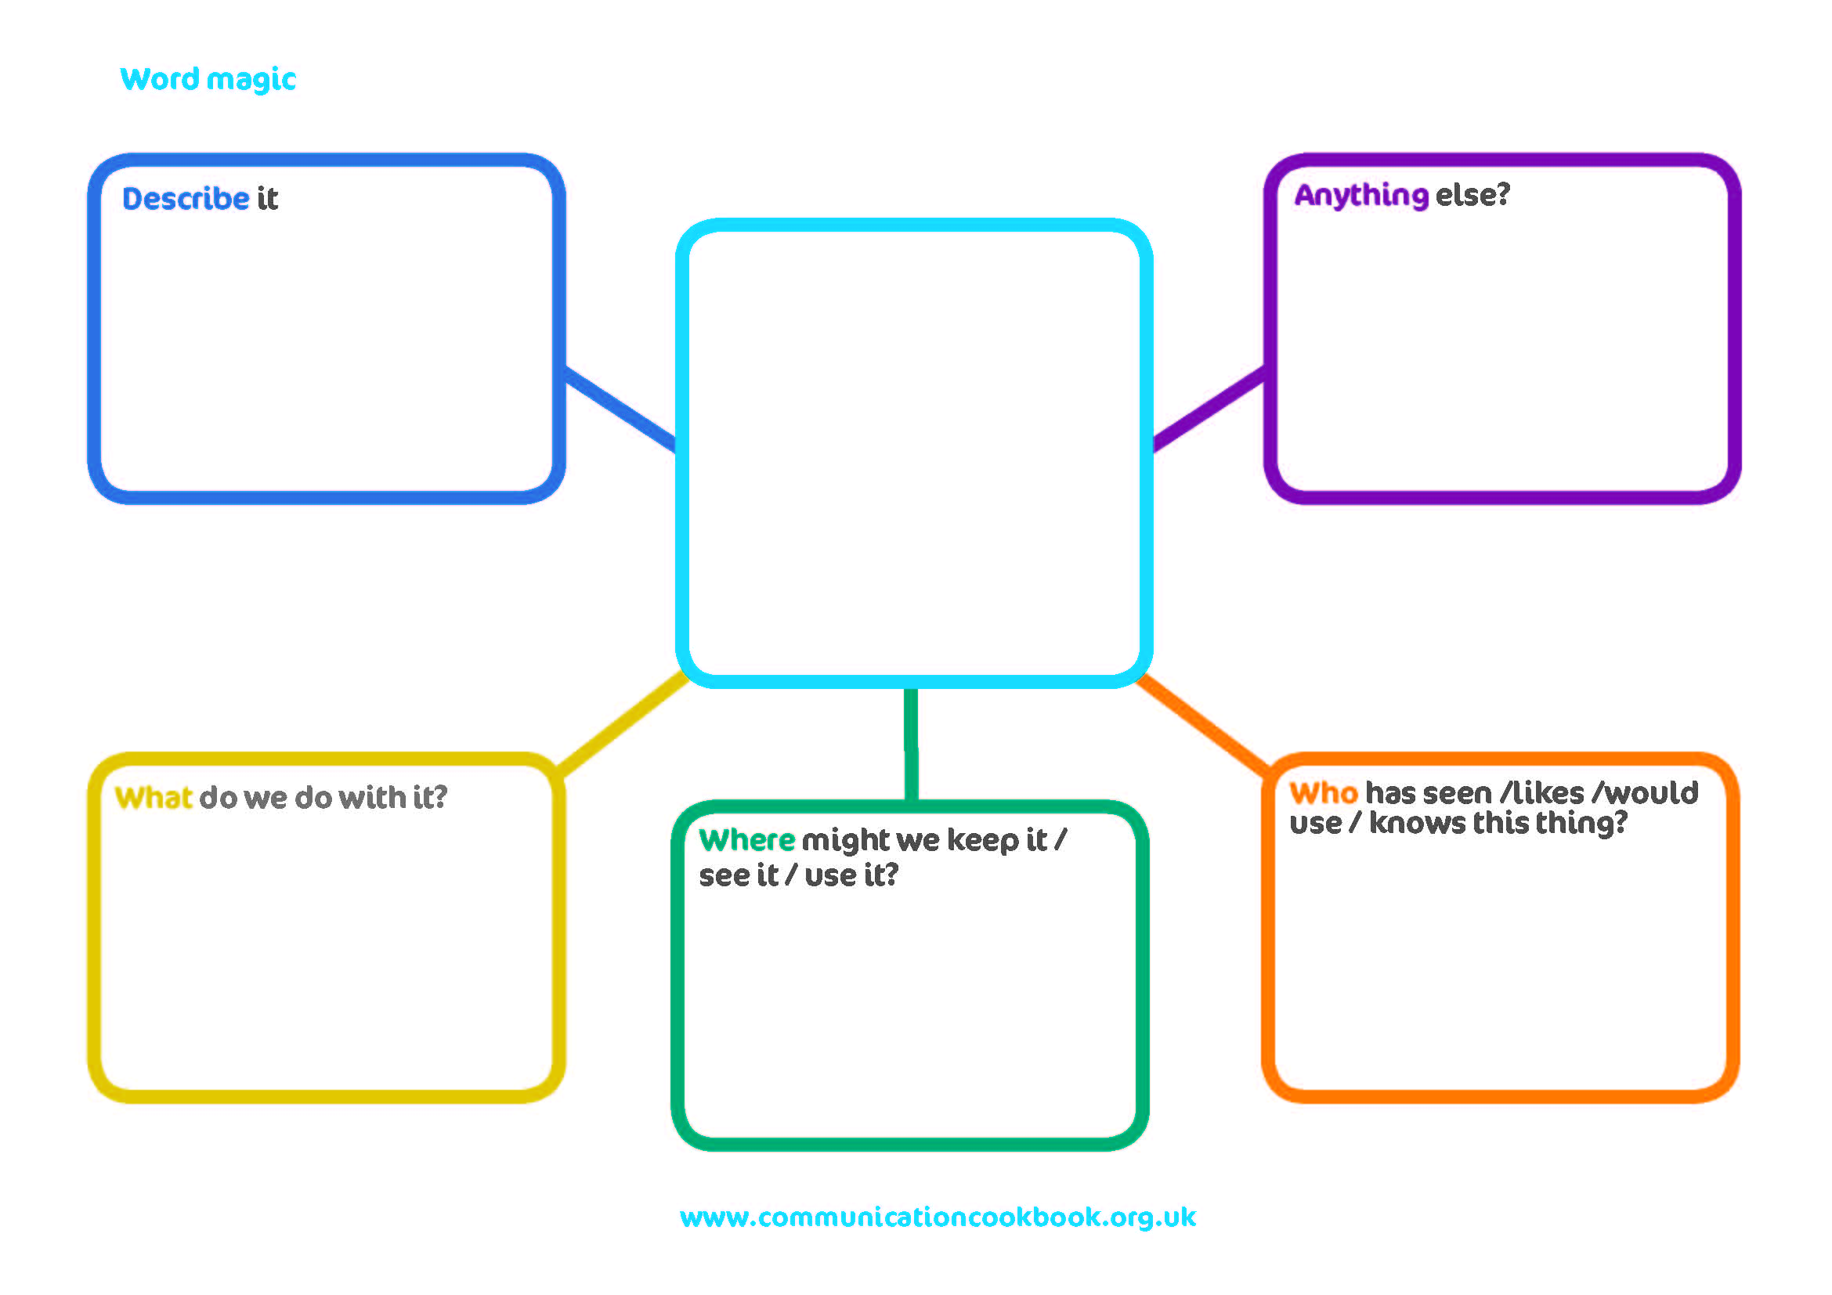
Guess who
This activity helps children to further understand important characters/people and develops use of adjectives through discussion and descriptions.
Spoken language and listening objectives:
- Understanding and use of adjectives and descriptive vocabulary
- Use language to debate and discuss
- Understand other’s points of view
Resources:
- Pictures of the characters/people that you’ll be discussing during the activity
Activity:
Tell the children that they’re going to hear a description of a character/historical figure etc. and their job is to guess who the person is from the description. Depending on how difficult you want to make this activity, you can give the students descriptions based on appearance, or to make it harder you could base your description on the character’s personality or motives, or you could do a mixture of both.
Once the teacher has modelled a description, encourage the children to have a go at doing their own – is the description effective enough for the other children to guess?
Extension:
This might spark a debate in the class... Maybe one person describes a character as brave, but someone else feels he’s more of a cowardly character? Encourage this sort of discussion during the activity to help children analyse and understand characters or historical figures in more depth.
Reflection:
- How did the children manage with more abstract descriptions? Were these harder? Why?
- How much descriptive vocabulary was used to really build up a picture of the person being described?
- Did most children participate in either having a go at guessing, or describing, or both?
- Were children able to resolve any differences of opinion about who it was that was being described?
Remember, remember...
This game can be a useful opener to help children recap on a previous lesson before moving on, or it can be a useful summary at the end of a lesson to help consolidate learning.
Spoken language and listening objectives:
- Listening to others
- Summarising information
- Asking for clarification
Resources:
- None needed
Activity:
Split the class into groups of approximately 10, or smaller groups for younger children. The aim of this activity is for the group to remember as many key facts or key words as they can from the lesson. Start the groups off with a topic such as ‘words associated with the vikings’ or ‘science words’ and see how far round the group you can get without any repetitions of words.
You can encourage children to use clarification strategies during this game – if they don’t understand the meaning of a word that someone has said, or they don’t understand how a word links with the topic, they can ask the child who has said the word to try to explain.
Extension:
Instead of just single words or short phrases, this game could be extended so that each child must also give a short description/explanation. For example, if the topic is science and you’re summarising parts of a plant, instead of just saying ‘root’, the child would also be encouraged to explain the function of roots.
Reflection:
- Was it easy or hard to remember important points that we’d talked about in the last lesson?
- Was it easy to think of something new if you were last to have a turn?
- Did everyone agree with the words that the other children said?
- Was it easy to ask for clarification? How did we do that?
Hide and Seek
This activity encourages children to develop and consolidate their understanding of key words and information from a lesson. It can be a useful activity to include as a plenary, or at the beginning of a lesson to remind children about a topic that you’re revisiting.
Spoken language and listening objectives:
- Understanding and using topic vocabulary
- Defining words
- Listening to others ideas and suggestions
- Using language to describe
Resources:
- Words/pictures/objects to hide that are associated with the lesson
Activity:
Hide some objects/words/pictures around the classroom. Children can work in pairs if they wish, or they can play individually. Ask the children to find one picture/word/object, tell the rest of the class what they’ve found and then say something about it. It might be a definition if it’s a word or an explanation if it’s an object, or a fact about a person in a picture. Give the opportunity for other children in the class to add to the definitions/explanations/facts until the class are happy that they’ve thought of all the useful information that they can.
Extension:
You can play this as a team game with the class. One team are the hiders and the others the seekers. The hiders hide several words/objects/pictures and the seekers need to find them based on clues that they’re given. For example, ‘try to find an object that we use in maths, you use it to measure angles and it fits in your pencil case’. The other team first have to guess what they’re finding and then go out to find it! The other team can also give clues about where the object is hidden if it’s tricky to find.
Reflection:
- Summarise the objects/words/pictures that you found and talked about – was it easy or difficult to describe/explain/define them?
- Was it helpful to get ideas from the rest of the class to help you?
- Did it help us to remember some of the things that we learned in the lesson? How did it help us?

